William Lyon Mackenzie C.I. 2012 AWS3M
GRADE 11 DIGITAL MEDIA
________________________________________________________________
Film Workshop
Angles and Composition:
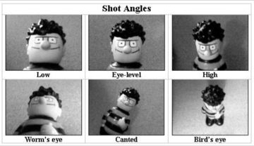
Important things to know
-The low angle is a camera angle that looks up at a character. This is the opposite of a high angle and makes a character look more powerful.
-The high angle is a camera angle that looks down upon a subject. A character shot with a high angle will look vulnerable or small.
-The eye-level angle puts the audience on an equal footing with the character/s. This is the most commonly used angle in most films as it allows the viewers to feel comfortable with the characters.
-The bird’s eye angle is an angle that looks directly down upon a scene. This angle is often used as an establishing angle.
-The Dutch or Canted angle is an angle that is achieved by tilting the camera off to the side. It is often used to portray the psychological uneasiness or tension in the subject being filmed.
-The worm’s eye angle is an angle from the view of an object from below. It is used in filming to look up to something to make an object look tall, strong and mighty.

Lighting:
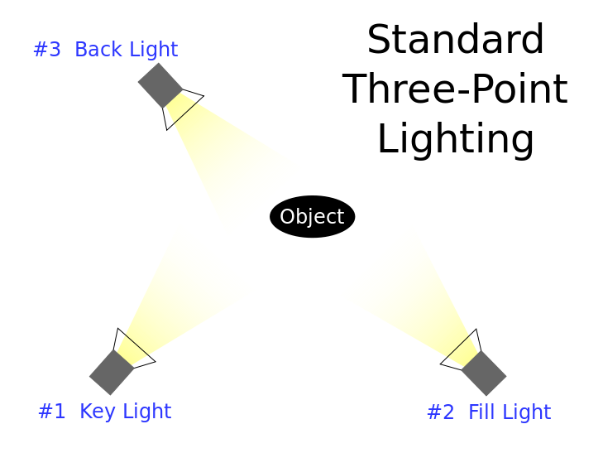
Important things to know
-The key light is the first and usually most important light in a lighting setup. It highlights the form and dimension of the subject.
-The fill light is used to reduce the contrast of a scene and provide some illumination for the areas of the image that are in shadow.
-The back light is used to illuminate the background area of a set. It also provides separation between the subject and the background.
Sound (Diegetic vs. Non-Diegetic):
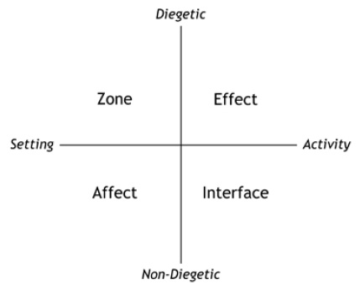
-Diegetic sound is sound that occurs in film that is natural. These sounds include doors opening and closing, footsteps, dialogue etc. Imagine that the film is real. If you could hear that sound in real life, it is diegetic.
-Non-diegetic sound is sound that is added to the film during editing. These sounds include music and songs that are added to the film, narration and special effects.
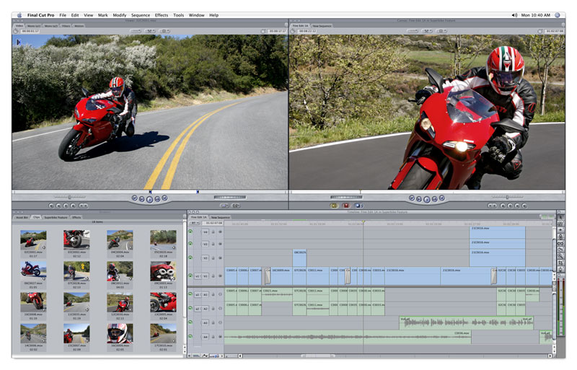
Editing:
Important things to know
-A jump cut is a cut in film editing where two sequential shots of the same subject are taken from camera positions that vary only slightly.
-A montage is a technique in film editing in which a series of short shots are edited into a sequence to condense space, time, and information.
-A cutaway occurs when a scene that is shot continuously is interrupted by another piece of footage.
-A dissolve is when one scene slowly fades into another. This is often done to show the link between two scenes or the passing of time.

The Basics of Screen Writing
-Listen to Your Imagination.
-Listen and Observe the World Around You.
-Brainstorm. A LOT.
-Visualize your main characters as actual people.
-Understand the “Three Act Structure”.
-Study the proper screenplay format.
-Write a first draft of your screenplay in three pages.
-Then rewrite, rewrite, rewrite, rewrite, rewrite, rewrite, rewrite. Screenplay writing is all about the rewrite.

