William Lyon Mackenzie C.I. 2012 AWS3M

GRADE 11 DIGITAL MEDIA

________________________________________________________________

Typography Workshop

LOGO

Example:



What It Conveys: Your logo basically conveys what your company is about. At first glance, the logo is recognizable and stands out from other logos. It needs to make your brand unique.

What It’s Used For: Your logo is used to promote your company and should be able to stand on it’s own as a company visual.

BUSINESS CARD

Example:



What It Conveys: Your business card is one of the most important components of your business because it gives your clients all of your key contact information and states your position in the company.

What It’s Used For: Your business card is your leave behind information. It keeps you in your clients’ minds.

WORD MARK

Example:

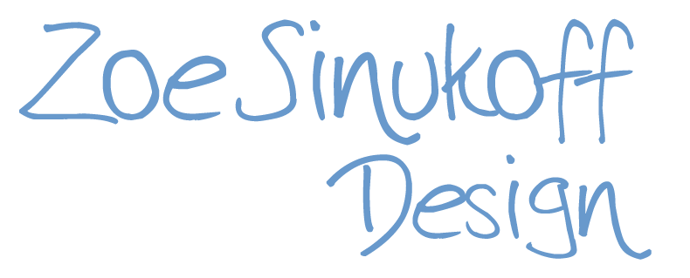

What It Conveys: The word mark is similar to the logo in that it shows your clients and customers more about your business only in a more personal way.

What It’s Used For: The word mark tells clients who you are and what you as an artist stand for. It is more related to you than to the entire company.

NEWSLETTER

Example:



What It’s Used For: The newsletter is given to clients or just to people in general to update them and give them information about what kinds of things you are working on.