Website Editing Instructions (Just in Case You Forgot!)
khattrascience.weebly.com

HOW TO MANAGE PAGES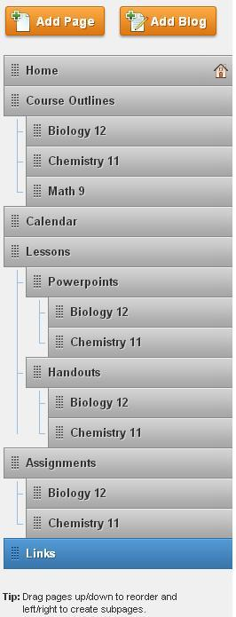
1. Go to weebly.com and sign in. Once you are signed in to your Weebly account, click on the site that you would like to edit.
2. At the top of the page, there is a link labeled “Pages”. Here, you will see all the menus and submenus on your website.
3. To ADD a page, click “Add Page” located at the top left section.
4. Give this page a name.
5. Choose the layout of the page by simply clicking on one of the four options
6. To DELETE a page, simply click “Delete Page” located on the right side and confirm.
7. To ORGANIZE pages, look at the whole list of pages on the left side of the screen (picture on right) and just drag the pages up/down. This will determine the order that the pages will appear on your website.
8. To CREATE SUBPAGES, look at the whole list of pages on the left side of the screen (picture on right). Drag the page that you want to move. Locate the page it’s going to be under and drag it beneath that page, moving it slightly to the right. A little blue line should appear once it successfully becomes a subpage.
9. Click “Edit Page” to get started in designing it!

HOW TO ADD TEXT AND PICTURES
1. At the top left corner of the page, click on “Basic”.
2. To add text, drag any widget that will enable you to write text (Title, Paragraph, Paragraph with Title) on the page that you wish to put it on to.
3. To add pictures, drag the widget called "Picture" or "Paragraph with Picture" on the section of the page that you wish to put it on to.

HOW TO ADD FILES
1. At the top left corner of the page, click on “Multimedia”.
2. Select and drag “File” on the desired page.
3. Click on it to upload file. A little icon should show up near the top of the page.
4. Select “Upload New File” and find the file that you want to post. Press “Open” to upload the file. Once uploaded, you can also change the file name and position of the file on the page using the icon near the top of the page.

HOW TO ADD YOUTUBE VIDEOS
1. At the top left corner of the page, click on “Multimedia”
2. Drag the icon “YouTube Video” on the page where you want your video to be. A sample video will show up on the page.
3. To change the video, click on the box where the video is but not on the actual video because clicking on the video will just play it. By doing this, an editing tab should show up near the top of the page.
4. Here, you can put the URL of the video you wish to post. You can also change the size and position of the video.
5. To delete the video, just click the red X button on the right side of the box.

HOW TO ADD HYPERLINK
1. Go to the page that you would like to post the hyperlink on to.
2. You can put a hyperlink on any text on Weebly. From the “Basic” menu, drag any widget that will enable you to write text (Paragraph, Title, Paragraph with Title, Paragraph with Picture)
3. Click to edit text.
4. Highlight the text you want to put a link on and click the icon that should say “Create Link” while hovering through it.
5. A new window should appear that will ask for the desired website URL. Copy and paste the URL in this text field. You can also choose to link your text with a page from your actual website. You can also link it to an image or to your email.
6. Click “Save” to save the changes.

HOW TO MANAGE CALENDAR
Since Weebly doesn’t directly have a calendar widget, a Google Calendar is used instead. To manage your calendar:
1. Log in to your Gmail account.
2. Click “Calendar” located at the top of the page. If it’s not on the top of the page, click on “More” and click “Calendar”. This will direct you to the actual calendar shown on your website.
3. To ADD an event, click on the day that your event is going to happen. Type the event title and press “Create Event” to finish.
4. To EDIT an event, click on the event to be edited and click “Edit Event”. Here you can edit the event title, event place, description, privacy, reminder, etc.
5. To DELETE an event, click on the event to be deleted and click “Delete”
6. The changes that occurs here will show up on your actual website.

